Tuesday 31st March 2020
LK: To make inferences based on an illustration.
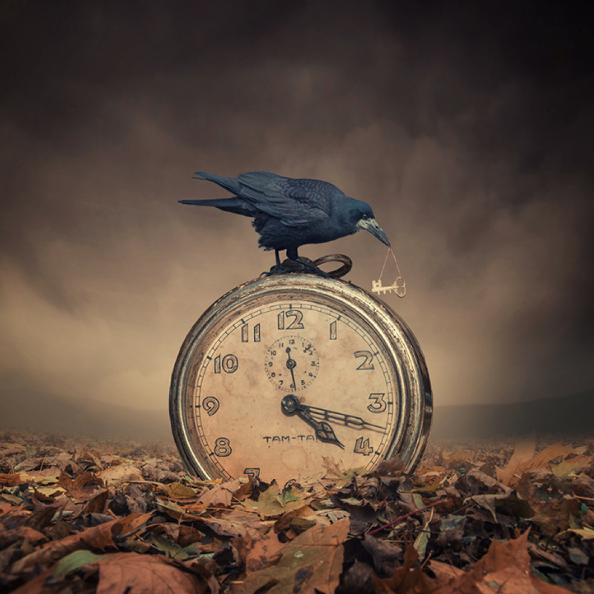

Your Task: Answer the following questions.

- What do you think the key is for?
- Why do you think the girl is so desperate to have it?
- Why do you think the crow has taken the key?
- How did the clock get there? Is it significant in the story?
- What do you think the crow is thinking?
- Where have all the leaves on the ground come from?

Now, imagine the object that the key fits into. Can you draw or describe it?

