Tuesday 21st April
L.K: To use multiplication methods to answer reasoning and problem solving equations
Yesterday, you went over short multiplication. Use your knowledge to complete the questions below. The answers will be at the end of the document.
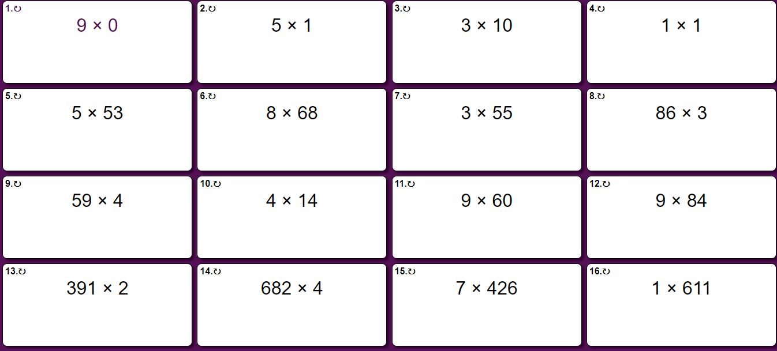
Now, you are going to use your knowledge to answer reasoning and problem solving questions. They will be 1, 2 and 3 star and choose what you feel comfortable attempting. Make sure to challenge yourself, you will never get better if you do work that is always easy!
1 Star
- Dogs have 4 legs and humans have 2. There are 11 dogs and their owners in a park. How many legs are there in total?
- A box contains 3 jigsaw puzzles. There are 250 pieces in each puzzle, so how many jigsaw pieces are in the box?
- 23 x 7 = _4_. What are the missing numbers? How do you know you’re correct?
2 Star
- If I turn in a full circle, I turn 360 degrees. How many degrees will I turn if I turn 4 full circles?
- In 4W, we each have two hands and two legs. There are 30 children in the classroom. In 4M, there are 60 legs and 60 hands. Which class has the most children?
- Oranges cost 39p each. How much would 9 oranges cost? Can you shown this in pounds and pence?
3 Star
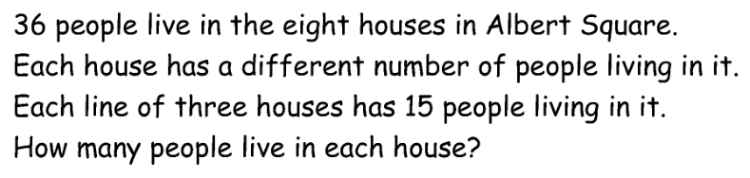

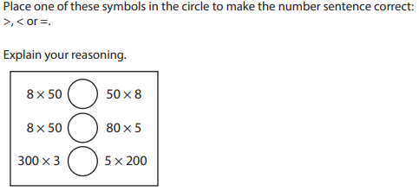

- Sally has nine times as many football cards as Sam. Together, they have 150 cards when they add them together. How many cards does each person have?
Extension:
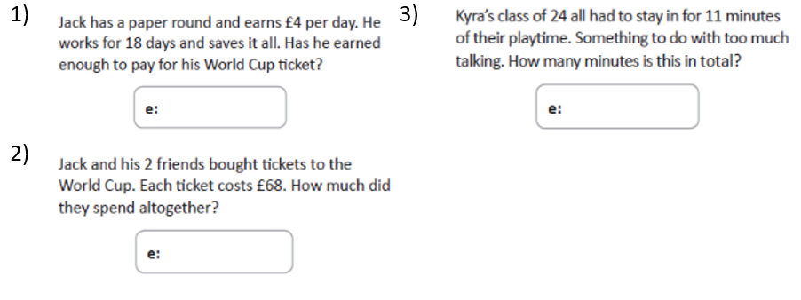
Answers:
