Plan for this week (20th to 24th of April)
We are going to be recapping short division and multiplication from Monday to Thursday. On Friday, there will be a short test and an opportunity to create a multiplication or division poster. There will be a prize for the best creation and this will be explained further in Friday’s work!
Finally, thank you for your continued engagement to your Home Learning and I am certain that this will really help you when you get back to school! If you want to show off your work or just to ask questions, please email WDV.Year4@oasiswoodview.org and I will get back to you.

Mr Crowe

Monday 20th April
L.K: To recap multiplication methods
Today we are going to look at using short methods of multiplication. This is the easiest and most efficient way of multiplying numbers and will be used throughout your school life! In Year 4 we have looked at multiplying 2 and 3 digit numbers by 1 digit. However, this method can be used to multiply any amount of digits by any other amount of digits.
The method is shown below:
Example,
Explained:
We start on the right and calculate 5 x 4, which is 20. The 0 goes in the box and the 2 is placed underneath.
2 x 4 = 8. 8 plus the 2 underneath is 10. The 0 goes in the box and the 1 goes underneath.
Finally, 4 x 1 = 4. Adding the 1 will make 5 and our answer is 500.
125 x 4 =
- 2 5

- x
5 0 0
1 2
Use the example to complete the following equations. You need to use the short method to work these out. This practice will be vital!:
- 45 x 3 =
- 75 x 5 =
- 63 x 7 =
- 145 x 3 =
- 263 x 6 =
- 710 x 5 =
- 868 x 8 =
- 921 x 9 =
One Star
- I have 17 pieces of gum in a packet. If I have 5 packets, how many pieces of gum do I have?
- “If I multiply 21 by 4, I get the answer 80.” Explain my mistake. Use short methods of multiplication to prove your answer.
- My local phonebox has windows with 24 panes of glass. If it has three windows and they each have 24 panes of glass, how many panes of glass are on the whole postbox?
Two Star
- Two hundred and seventy four multiplied by 9 equals?
- A tree has 174 leaves. There are 9 identical trees in a park. Estimate how many leaves are on all of the trees and then work out the correct answer!
- A tiger has 13 orange stripes and 14 orange stripes. There are 4 tigers in a forest. How many:
a) Orange stripes are in the forest?
b) Black stripes are in the forest?
c) Orange AND black stripes are in the forest altogether?
- Oranges cost 39p each. How much would 9 oranges cost?
Three Star
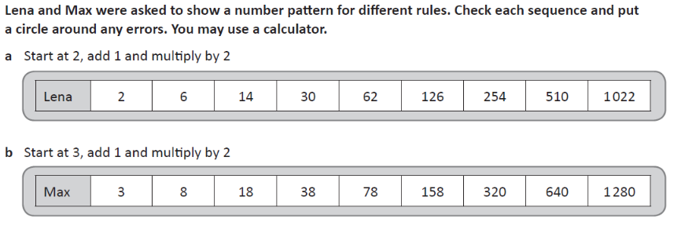

- I have a box of 459 marbles. My friends each make a box containing 459 marbles. There are now 8 boxes of marbles, so how many marbles do we have altogether? Is it more or less than 5000?
- Prove why 328 x 9 does NOT equal 4214. What mistakes have been made?
- Horatio buys a model ship. He calculates that there are 14 sails on his ship and there are 20 identical ships in the shop. How many sails are in the shop:
a) Before he buys his model ship?
b) After he buys his model ship?

