Monday 20th April 2020
L.K: To infer meaning from a picture
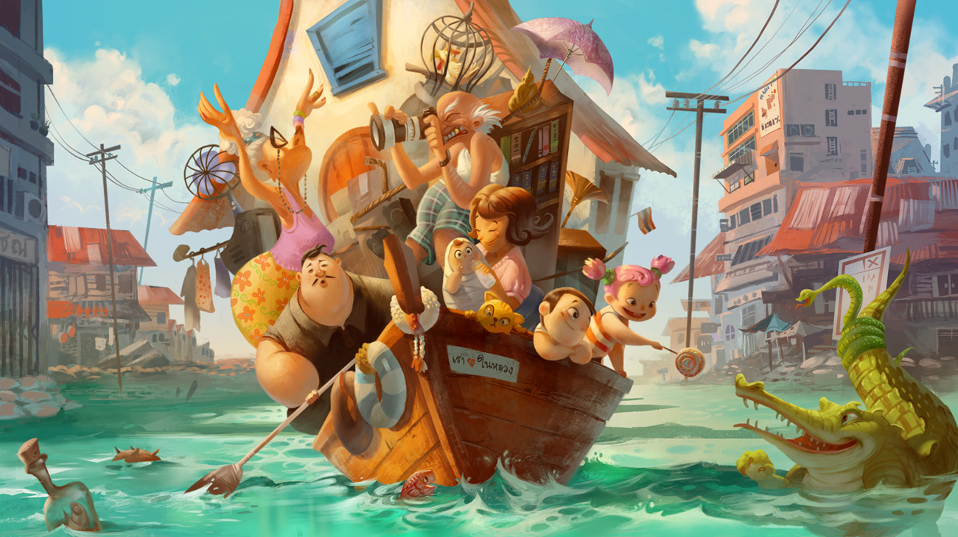
When we infer meaning, we are looking deeper at what something is telling us. For example, if somebody was upset, you would expect to see that they may be crying, have a red face or have a sad look on their face. However, inference does not always use words, sounds or even movement! You can look at an image, such as the one below, and infer what is happening and what each character could be feeling.

Your task:
- The picture above could be a painting in an art gallery. What do you think its title could be? Look carefully at what is going on before you make your decision and make your title relevant to the image!
- Pick at least four of the characters in the picture above. How do you think they are feeling in the picture? Why do you think this?
- There is a bottle in the bottom left of the image. What message do you think is in the bottle? Can you rewrite it? This only needs to be around 3 lines long!

- Now pick your favourite character from the image. What do you think has happened to them to get to this point in the picture? How do you think their day has gone so far? This will be a chance for you to write from a character’s point of view, so you need to add detail and emotion! I have supplied an example below and you are welcome to follow, but have a go at your own if you’re confident!
Before you start, make sure to make a mind map of all of your ideas so that you can make a concise and flowing story.

The Black-haired Man
I woke up this morning to the sound of running water and the smell of damp wood. A slow trickle of rusty brown liquid made its way from the ceiling to splash loudly onto my face. “Drip, drip drip…”. I shot out of bed, partially because of the foul smell of the leaking water, partially because of the loud banging on my front door!
“GET UPPPPPPP!” exclaimed my early morning visitor, “THE NEXT WAVE IS COMING!!”. Springing into action, I grabbed my phone, keys and wallet and got dressed at lightning speed as a low rumbling sound grew louder and the wind outside intensified…

