**Maths Friday 26.06.2020**

If you do not have a printer, this can be done on paper

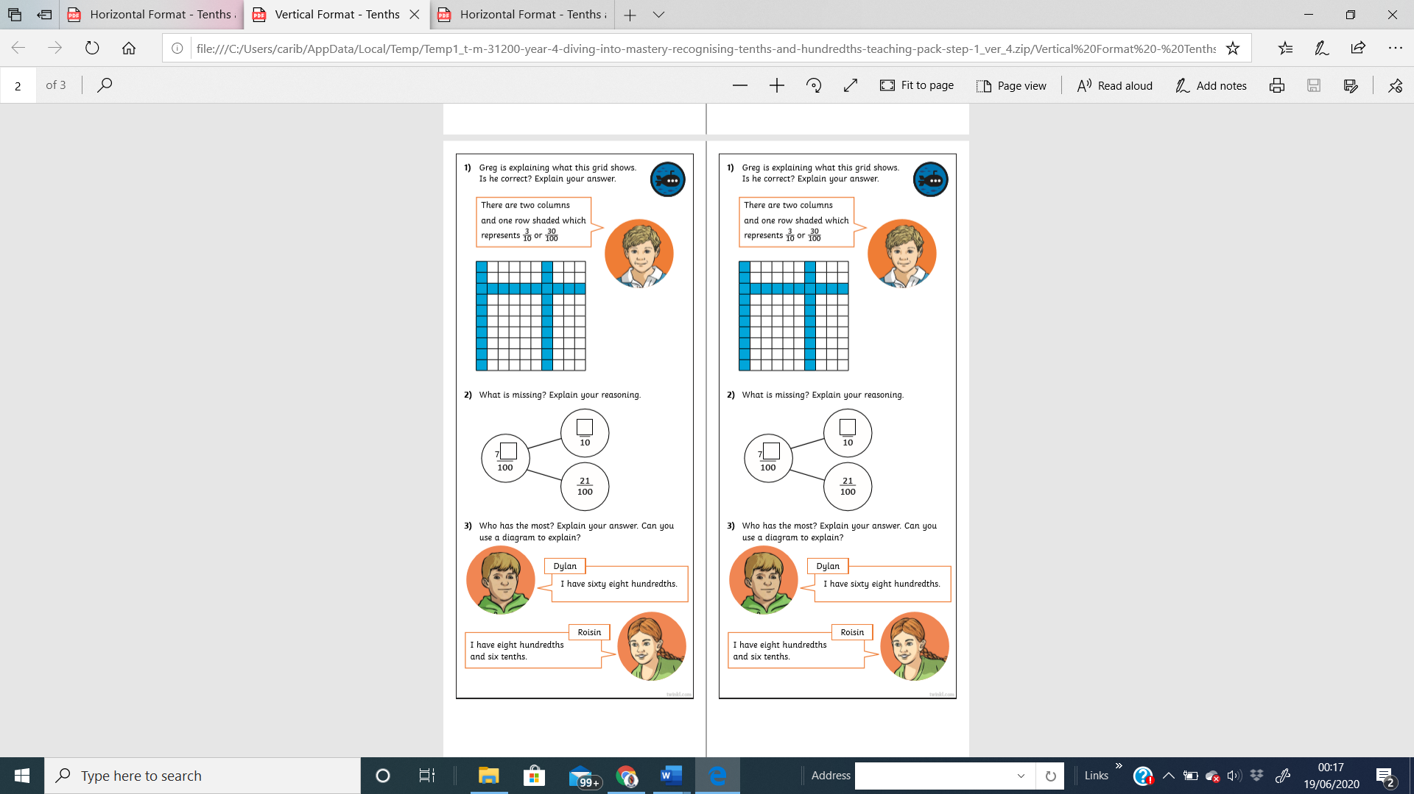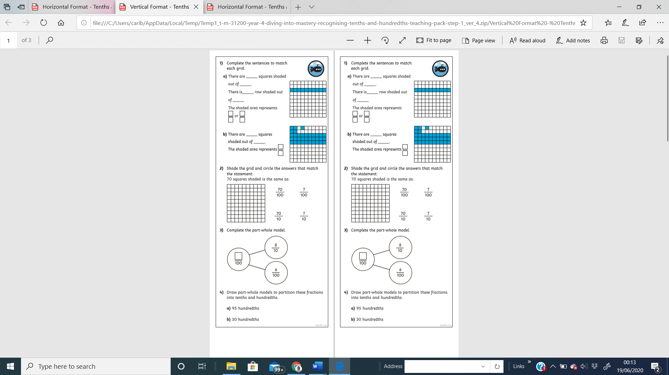Fluency Reasoning