Friday 3rd April 2020
L.K: Continuing to recap addition and subtraction
This will be the final day of planned work on addition and subtraction. Therefore, I will be giving starter questions, reasoning and problem solving questions and then an optional test! If you would like to, please send me the results as I am really interested in how you’ve done! Send them to WDV.Year4@oasiswoodview.org for me to look over.
Starter
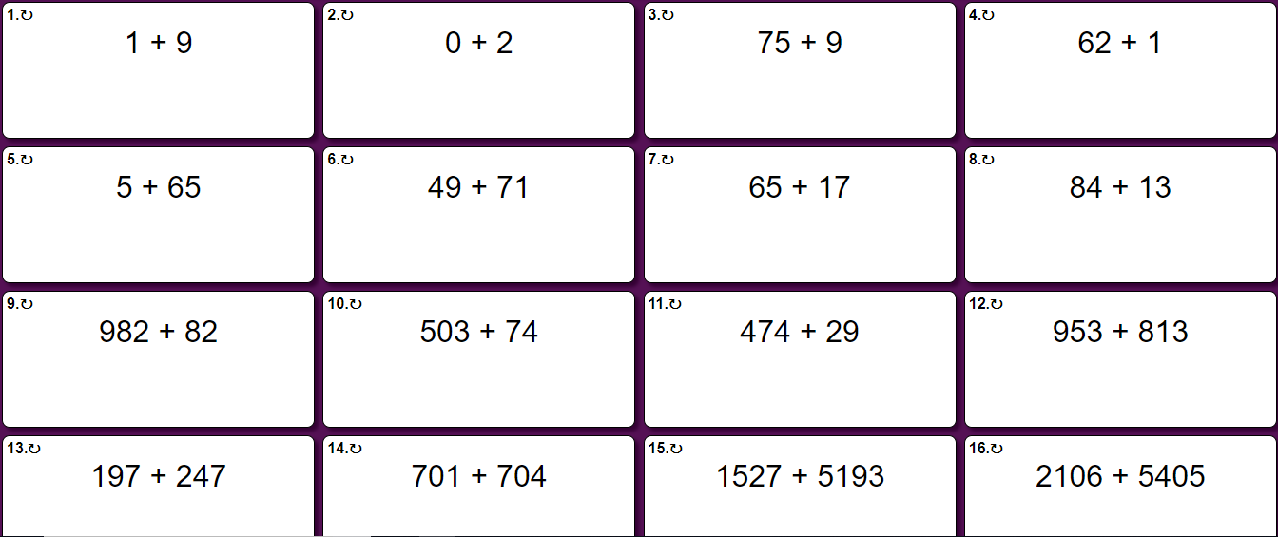
Reasoning and Problem Solving
ONE STAR
- A bike costs £250. However, I want it sprayed fire red and I want the new all road tyres. If they both cost £80 each, how much have I spent in total?
- 1000 people are in a park. 450 are playing football and 300 are sunbathing. How many people aren’t doing either activity?
- Yellow is not a popular car colour. Only 25 people have that colour for every 1000 cars! How many people DON’T have a yellow car?
- Andy keeps losing cheese to a greedy mouse! He had a 2000g block of cheese, but after two days he has found that he only have 1500g left. How much could the mouse have eaten per day?
TWO STAR
- Andy is reading a book which has 950 pages. He read 150 pages in the morning and 257 in the afternoon.
How many more pages has he left to read?
- Sam buys a big box of biscuits. He estimates that there are 5000 biscuits in the box. He eats 460 in a month and gives 1300 away to his friends. How many are left at the end of the month?
- A porcupine is an animal with a lot of spiky needles. On it’s body, it has 3000 spikes! If he loses 1500 in a fight with a lion, but grows 3200 back, how many spikes would the porcupine be left with?
THREE STAR
- Dan scored 1105 points on his computer game on Monday and then 510 on Tuesday. On Wednesday he lost 433 points.
What was his total score?
- Pat had 897 cards. This morning she won another 700 cards from a friend but then lost 2100.
Do you think Pat’s Maths is correct?
- Ben scored 1950 points on his computer on Monday and 3212 on Tuesday.
On Wednesday he lost 2410 points.
What is his total score?
- Andy keeps losing cheese to a greedy mouse! He had a 5000g block of cheese, but after two days he has found that he only have 1500g left. How much did the mouse eat if he ate an equal amount per day?

ANSWERS
