Topic, Science and Spanish activities
Week Beginning 30th March 2020.
Scrumdiddlyumptious!
This was our topic right back in September! Do you remember it? A journey of discovery through fantastic fruits and venerable vegetables.
You could try these Scrumdiddlyumptious tasks at home this week:
- Keep a food diary of everything you eat and drink for a week. Report back: In your opinion, does your family have a healthy balanced diet?
- Cook something! Choose a dish from a recipe book or cook with your family. Take some photos and send them into the Year Three email address.
Science: Movement and Feeding
We learnt about how our bodies move and how to keep them healthy. Try these tasks this week:
- Design an exercise routine for you and your family. Your exercise routine should last for about 10 minutes. Remember to measure your heart rate before you start and after you finish.
- Make a poster or leaflet about the importance of exercise.
Spanish
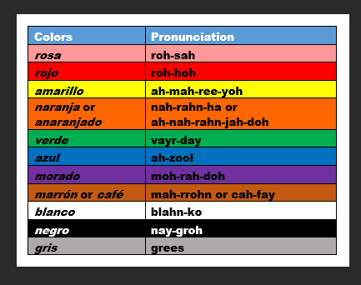
We have learnt how to say our colours in Spanish- could you teach a member of your family how to say them too?
HAVE FUN AND STAY SAFE!

