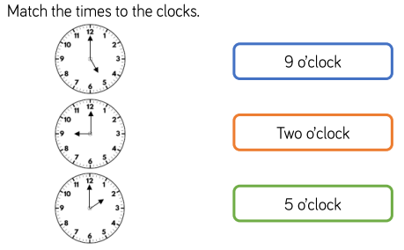
1.

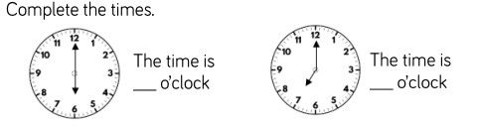
2.

3. Challenge:
Tell your child about ‘Little Red Riding Hood’ visiting her grandma… Write the time shown on the clock or draw on the hands to show the time.

