English: Home Learning Monday Week 12

The Lighthouse Keeper’s Lunch Reading Comprehension

Watch the story on Youtube and answer the following questions:

https://www.youtube.com/results?sp=mAEB&search_query=the+lighthouse+keepers+lunch+

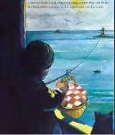
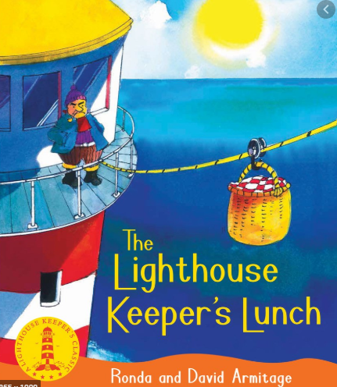
Remember to answer in sentences.

1. Where was Mr and Mrs Grinling’s little white cottage?

2. Which word describes Mr Grinling as a hard worker?

3. Why did some ships toot at night?

4. Write about a plan which did not work.

5. Write about the plan which stopped the seagulls from eating Mr Grinling’s lunch.

