Week 10 – English- Year 1 Wednesday

The Boy Who Lost His Bumble
Watch the specific part of the story below again about The Boy Who Lost His Bumble by Trudi Esberger on Youtube.
https://www.youtube.com/watch?v=-sjDj_XBaJ0
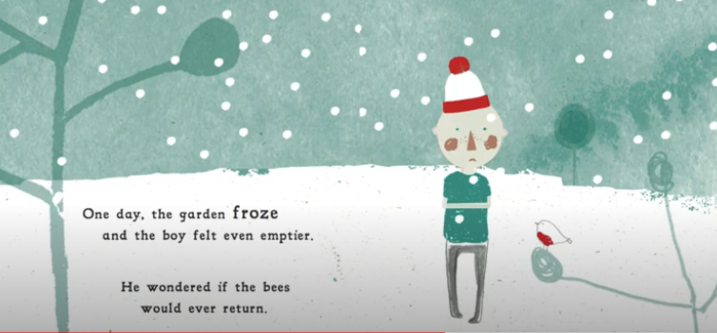

Edit some of your writing from yesterday. How can you make your sentences better? Have you used some adjectives and expanded noun phrases in your sentences? Did you use at least two of the Fantastics? Read your version of the story to your family.

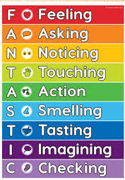
Success Criteria:
Recall specific events in the story
Use the illustration to continue writing
Use adjectives and expanded noun phrases

