Week 10 – English- Year 1 Tuesday

The Boy Who Lost His Bumble
Recap the story again about The Boy Who Lost His Bumble by Trudi Esberger on Youtube.
https://www.youtube.com/watch?v=-sjDj_XBaJ0
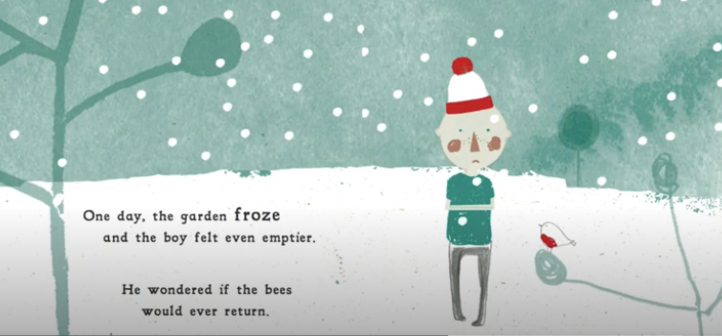

He tried to keep busy with other things but it was no good. He had almost given up when… Continue your version of the story.

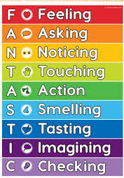
Success Criteria:
Recall specific events in the story
Use the illustration to continue writing
Use adjectives and expanded noun phrases

