Week 10 – English- Year 1 Monday

The Boy Who Lost His Bumble
Watch the story The Boy Who Lost His Bumble by Trudi Esberger on Youtube.
https://www.youtube.com/watch?v=-sjDj_XBaJ0
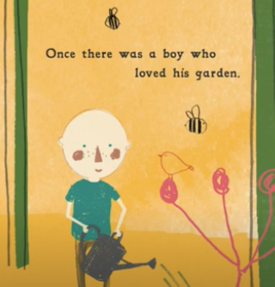
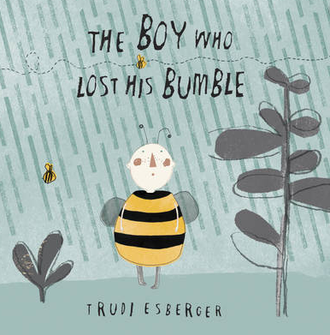

Have a look at first part of the story again. This is where the ‘bees lost their bumble’ and ‘the boy felt empty’. Write some sentences about how the boy is feeling ‘because things weren’t the same anymore’.
Success Criteria:
Listen to the story and recall the events
Discuss how the character is feeling
Write sentences with accurate punctuation

Challenge:
Think about the main character’s emotion and write what you have noticed. Use the Emotion and Feeling Wheel to help you write some more interesting sentences.
