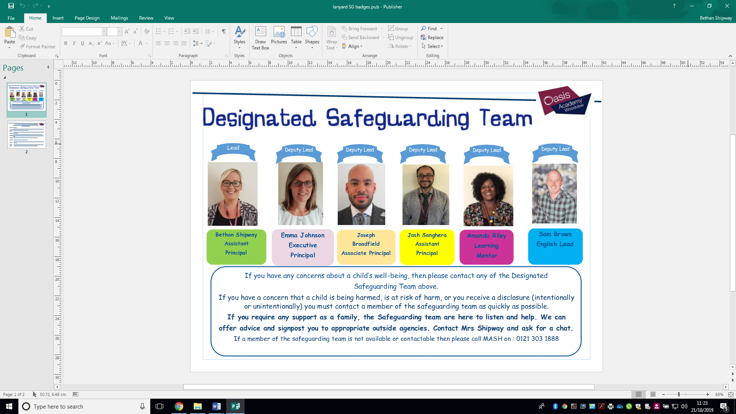

**Safeguarding**

**at Oasis Academy Woodview**

**Do you know your Safeguarding team?**

**Please speak to the office to arrange a meeting with a member of our team.**

Dear Parents and Carers,

Welcome to the Spring Term Part 1 Safeguarding Newsletter. Safeguarding the children within our school continues to be at the top of our agenda and is at the core of the work we do.

Working with parents and our local community is key to ensuring your children are kept safe. We hope this newsletter continues to provide you with up to date and relevant information.

As always, please do let us know if there is anything specific you would like to know more about.

If you require any support, we have developed

some useful signposting information to different

agenices in the Local Authority that are proving

to be useful to some of our families, so please contact a member of the DSL team should you need it.

**Do**

**you**

**need**

**talk**

to

someone?

to





**The Safeguarding Team are here to help in any way we can. Please come and see us if you need any support.**

**Junior PCSOs**

Our Junior PCSOs are out in full force each week trying to keep our children, parents and the public safe during their walk into and around school in the morning.

We have a new PCSO who has joined our team, PCSO Scott Ohren who will be coming to support our Junior PCSOs from time to time.

Please look out for our new signage to promote safer

parking outside the school also.

After half term we will be outside the school during the mornings and afternoons more often, so please continue to follow the parking restrictions and avoid parking on the yellow lines outside the school.

We will continue to provide warning tickets for those cars caught parking unsafely in the first instance but these will be escalated to the police for ticketing if it continues. Thank you for your continued support.

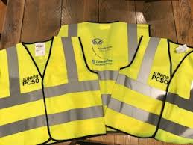

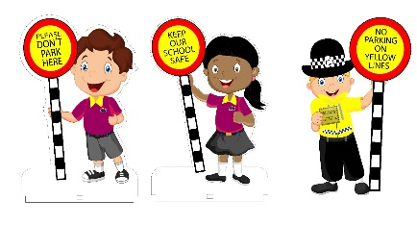



It has 1 billion active users across 155 countries

All content uploaded is available to anyone- even if they are not registered to TikTok

Anyone you ‘add’ on the app can privately message you

There are only two privacy settings;

Private: only the creator can watch their videos

Public: anyone on the app can view videos (this is the default setting)

TikTok is a social networking smartphone app, based around the use of video

Users must be 13+ to register

Most users of TikTok are under 30 but there is no way of knowing the age of the person that you are communicating with

Other schools have been reporting that children are uploading videos of themselves with their real names, school logos and other personal data. This is a real risk to our children as they can be easily identified and targeted using this information

**Social Media – TikTok**

While most interactions harmless, TikTok is prone to predators due to the high volume of its young users

**Please talk with your children about how to stay safe using apps and online.**

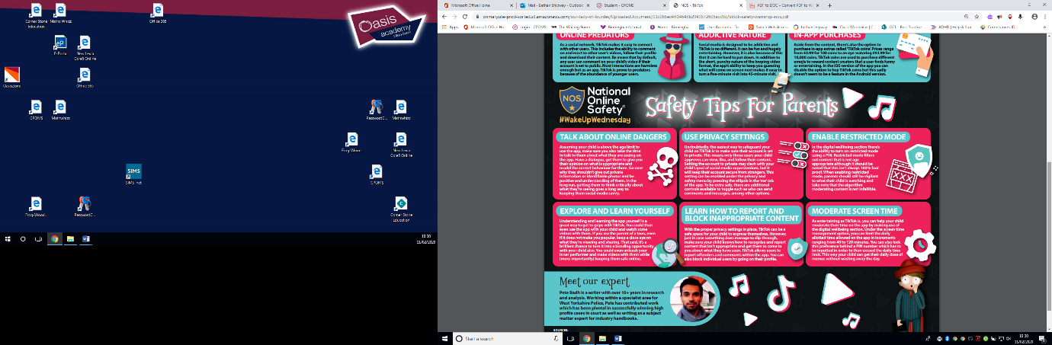

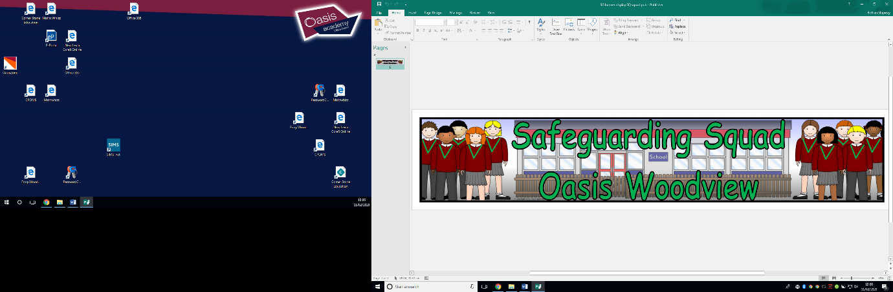

**9 Habits**

**February – Compassionate**

**March – Forgiving**

After half term our 9 Habits will be focusing on the habits compassionate and forgiving. We will continue working with all our children during assemblies and wellbeing class sessions to explore how we can use and apply these in our everyday interactions.

Please speak with your children at home about how they can incorporate these habits outside of school as well.

Our Safeguarding Squad are currently devising their own projects to support children across the school, including giving up their play time to read with the younger children in our Reception classes. They are also looking at new and fun ways to raise money for areas of safeguarding they are interested in, including; friendship clubs, safer roads and attendance improvement.

Look out for upcoming projects!

**Looking forward to next half term’s Safeguarding events….**

*Oasis empowerment fortnight* 9th-22nd March – please look out for a letter explaining how you can support the school in raising money alongside other Oasis Academies across the country to support gender equality