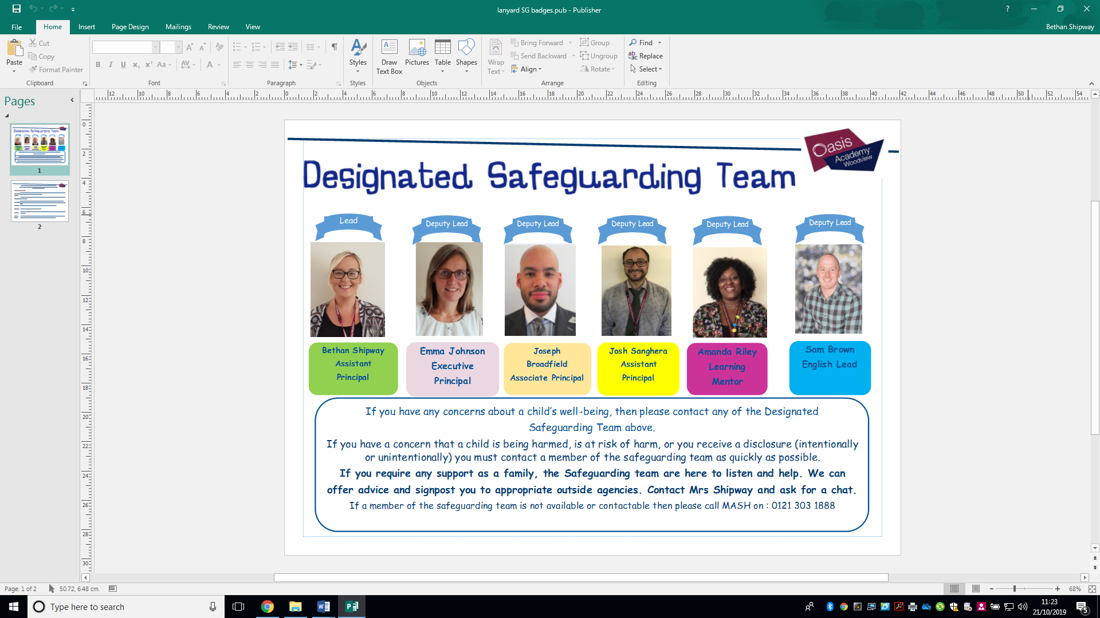

**Safeguarding**

**at Oasis Academy Woodview**

**Do you know your Safeguarding team?**

**Please speak to the office to arrange a meeting with a member of our team.**

**Looking after yourself and each other**

Christmas can be a really stressful time of year, whether you struggle with your wellbeing or not. There’s pressure to socialise with friends and family, more temptation to overindulge in food and drink and of course the financial strain to buy the right presents and all the celebrations can put on your bank balance. Sometimes, the last thing we feel like doing is talking to people. You might be feeling anxious, or overwhelmed, or just not very sociable - but connecting with other people has lots of benefits for your wellbeing. Talking through things that are worrying you can be really helpful, just sharing whatever it is can help you feel supported, and listened to. Christmas can also be a really good time to get in touch with people you might not speak to regularly - and you never know who might need a listening ear.

If you are concerned that you or someone you know are experiencing concerns around wellbeing, please [seek the advice and support of your GP](https://www.mentalhealth.org.uk/publications/gp-visit-guide) or local A&E. This website; <https://the-waitingroom.org/> also has some fantastic contacts to help with lots of areas of need. Or come in and speak with one of our DSL members.

**Do**

**you**

**need**

**talk**

to

someone?

to



**The Safeguarding Team are here to help in any way we can. Please come and see us if you need any support.**

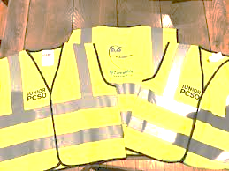

**Junior PCSOs**

Our Junior PCSOs have now completed their course and received their uniforms – Congratulations!

School are liaising with our Local PCSO to arrange days and times when the Junior PCSOs will be patrolling the path outside our school. They will ensure all cars are parking appropriately so children and adults entering or leaving our school are safe. Please ensure that during drop off and pick up you are abiding by the yellow markings that are in place.

They will first issue warning tickets to allow drivers the opportunity to follow parking laws. If the same cars are seen again parked incorrectly then this information will be passed on to PCSO and could result in a parking fine.

We have had lots of parents talk about the dangers of our road outside and the parking that takes place. We hope that this will help reduce the number of cars parking incorrectly and ensure our children and families feel safer coming into school.



**E-SAFETY**

It’s that time of year again, and with the Christmas shopping well under way many of us will be buying digital devices for our children, with technology continuing to feature high on those wish lists for Santa. Mobile phones, tablets and laptops can open up a world of exploration, learning and fun and children should be encouraged to make the most of the benefits. But there are also risks and dangers to being online, and by working together with your children they can learn to safely navigate the internet and social media. Below is a list of useful tips:-

1. Explain how children can use privacy settings to make sure only approved friends can see posts and images, and warn them about sharing personal information

2. Check if any of the mobile apps they use have location services enabled, and disable this if they do not want to be tracked

3. Show them how to report offensive comments or block people who upset them

4. Check ‘tagging’ settings so that when others are posting or sharing photos online, your child’s identity is not revealed

5. Encourage your child to come and talk to you if they see anything that upsets them

6. Ask them to show you which social media apps they use, what they like about them and talk about how to use them safely

**Looking forward to next half terms Safeguarding events….**

Holocaust Memorial Day 27.01.20 and Martin Luther King Day 20.01.20

International day of Zero Tolerance 06.02.20

Internet Safety day 11.02.20

Fairtrade fortnight starting 24.02.20









**9 Habits**

**January – Patient**

**February – Compassionate**

After half term our 9 Habits will be focusing on the habits patient and compassionate. We will continue working with all our children during assemblies and wellbeing class sessions to explore how we can use and apply these in our everyday interactions.

Please speak with your children at home about how they can incorporate these habits outside of school as well.

The DSL team, Safeguarding Squad and all members of our Oasis Woodview community would like to wish all our families a safe and happy holiday and we look forward to seeing you back on January 7th.

