|  |  |  |  |  |
| --- | --- | --- | --- | --- |
| Oasis Woodview Newsletter  **Friday 25th January 2019**  faces_line |  | |  | | --- | | O:\ADMIN\Logos and letterheads\Oasis Academy Woodview  Logos and letterheads\Woodview (print).png | |  | |
|  |  |  |
|  |  | In This Issue: |

.

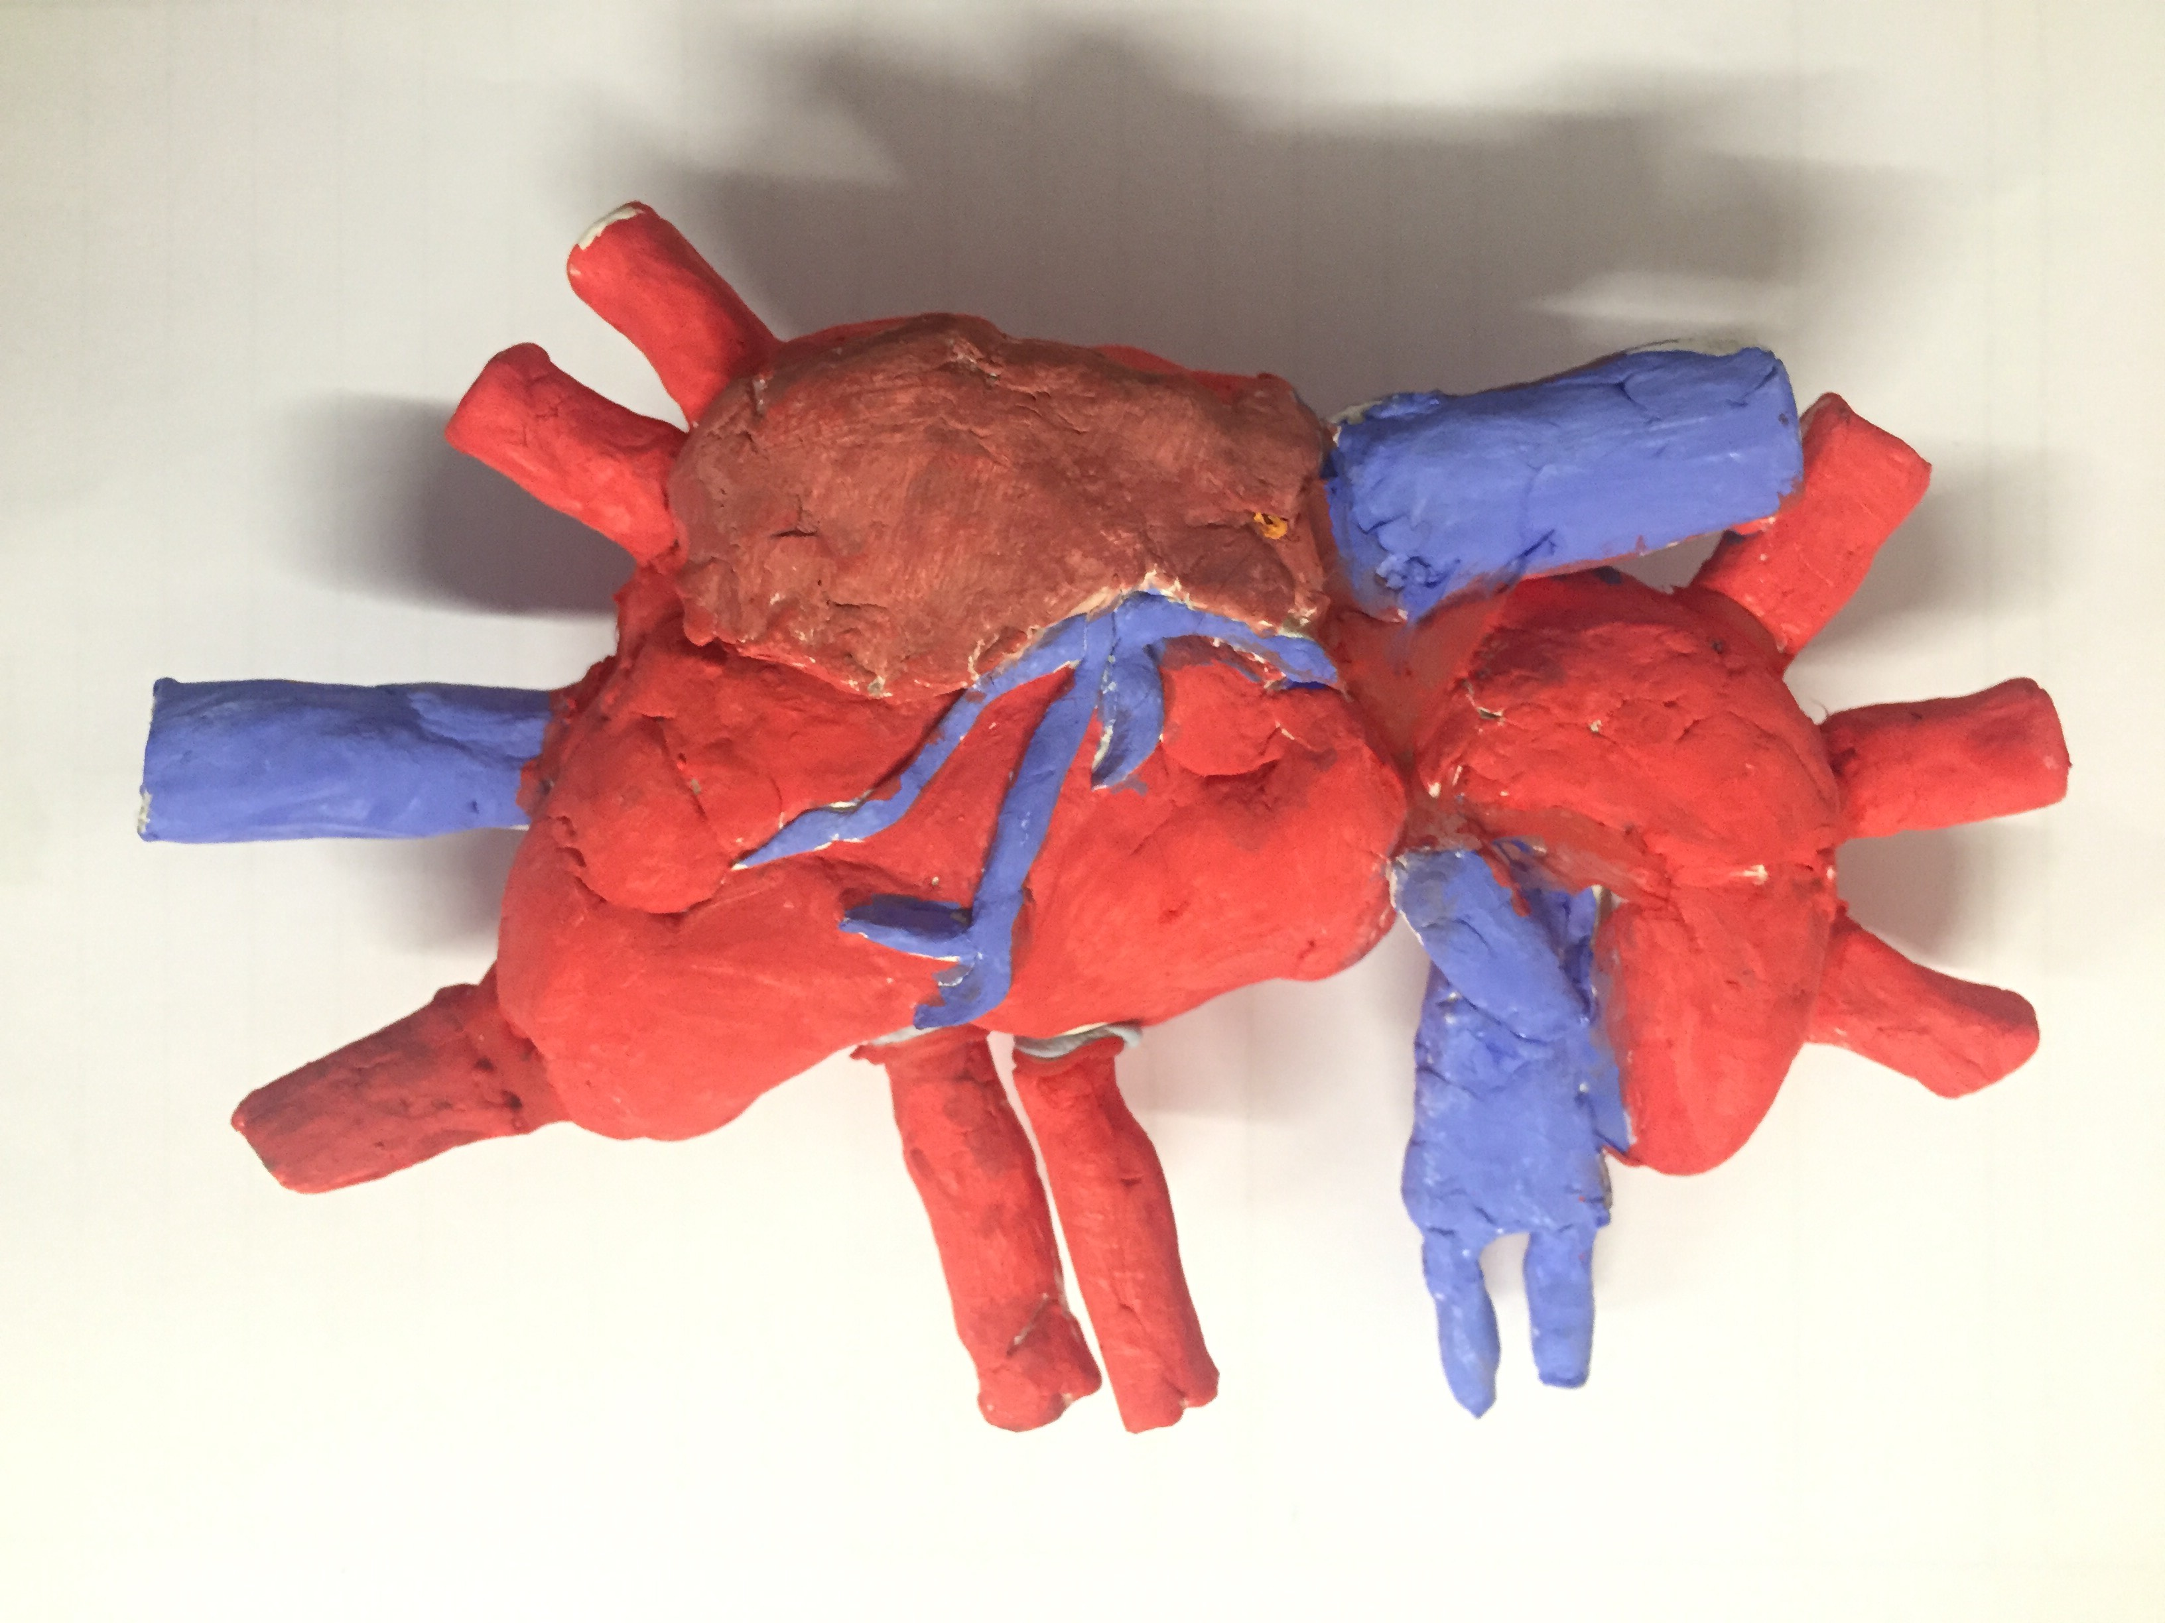.

**Clay Model of the human heart by one our Year 6 students**

**Year 6 New Topic: Blood – Heart**

Year 6 have had an exciting start to the year, becoming fully emerged in their new curriculum topic, **Blood Heart**. This is what the children have been involved in so far: They dissected a cow’s heart and identified all the major components. They also made fake blood, separated the different elements and observed the mixture. What an incredible start. Throughout the course of this topic the teachers have worked very hard with the children to raise awareness of blood and organ donations to save lives. Year 6 are thoroughly enjoying their learning and we would like to thank you for your ongoing support at home.

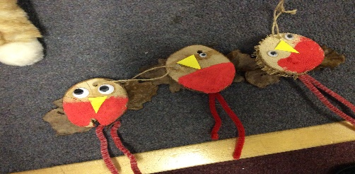

**Polite Reminder:**

**Parking at Edgbaston Community Centre**

Can we remind parents/carers that parking at the community centre is strictly for the use of the centre facilities. If you are dropping or collecting your child you may park on site only for a short period of time and only if a space is available. Thank you.

**Fully Funded Level 2 Courses for Parents.**



Oasis Community Learning have an amazing opportunity for our parents here at Woodview. There are a wide range of Level 2 courses (*such as* *Understanding Children and Young People’s Mental Health, Counselling Skills and* *Understanding Autism*) that are now available for free through our partnership with “The Skills Network.”

To register online (and find out more about each course), all you will need to do is visit the site: https://oasiscommunity.theskillsnetwork.com/

.

**Lunchtime Supervisor/Play Leader Vacancy**

We are looking for an excellent individual who is able to lead play at lunchtimes and work with our team serving and supporting children. If you are interested, please contact the school office.

**Year 1 Roots for Fruits**

Year 1 have been very busy with their outdoor learning experience. The children participated in some bird spotting exercises and even created their very own robins using natural outdoor resources. They walked around the school grounds and looked for evidence of some natural habits and created their own spider webs using sticks and wool. What a wonderful experience. Well done Year 1.

**Spring and Summer Term Dates**

**Half Term Holiday:**

Monday 18th February 2019 to Friday 22nd February 2019

**Return to school:**

Monday 25th February

**Easter Holiday Starts**: Monday 15th April 2019

**Summer Term Starts:** Monday 29th April 2019

**Half Term Holiday:**

Monday 27th May 2019 to Friday 31st May 2019

**Return to School:**

Monday 3rd June 2019

**Summer Term Ends:** Monday 22nd July 2019