|  |  |  |  |  |
| --- | --- | --- | --- | --- |
| Oasis Woodview Newsletter  **Friday 8th March 2019**  faces_line |  | |  | | --- | | O:\ADMIN\Logos and letterheads\Oasis Academy Woodview  Logos and letterheads\Woodview (print).png | |  | |
|  |  |  |
|  |  |  |
|  |  | In This Issue: |

****

**Oasis Academy Woodview will be hosting a Book Fair in the small hall with hundreds of new children’s books to choose from. There will be a wide variety of authors available ranging from Roald Dahl to Cressida Cowell. Prices will be starting from £2.99. Parents can come along with their children between 3.05pm and 3.45pm, week beginning 18th March 2019 until 21st March 2019 to browse and buy their favourite books.**

**Celebrate Reading at our Book Fair.**

**mmm…did someone say pancakes?**



**On Tuesday 5th March, children at Oasis Academy celebrated Pancake Day by indulging into a delicious pancake, smothered in a rich sauce, topped by sprinkles of sugar. Yum yum.**





**Weekly Class Attendance**



|  |  |
| --- | --- |
| RECAA – 93.9% | 3Z – 96.1% |
| RECBB – 94.7% | 4W – 93.7% |
| 1CC – 95.4% | 4M – 96 % |
| 1DD – 95.7% | 5M – 94.8% |
| 2EE – 95.8% | 5B – 96.5% |
| 2FF – 96.2% | 6 Lewis – 96.2% |
| 3C – 94.4% | 6 Lenny – 97.9% |

hhhh

**Bell Boating**

**As part of their ‘Flow’ topic, Year 3 had the privilege of embarking on a great journey through the canals of Birmingham via bell boats. Despite the weather, Year 3 thoroughly enjoyed the experience and worked extremely well as a team. Well done!**

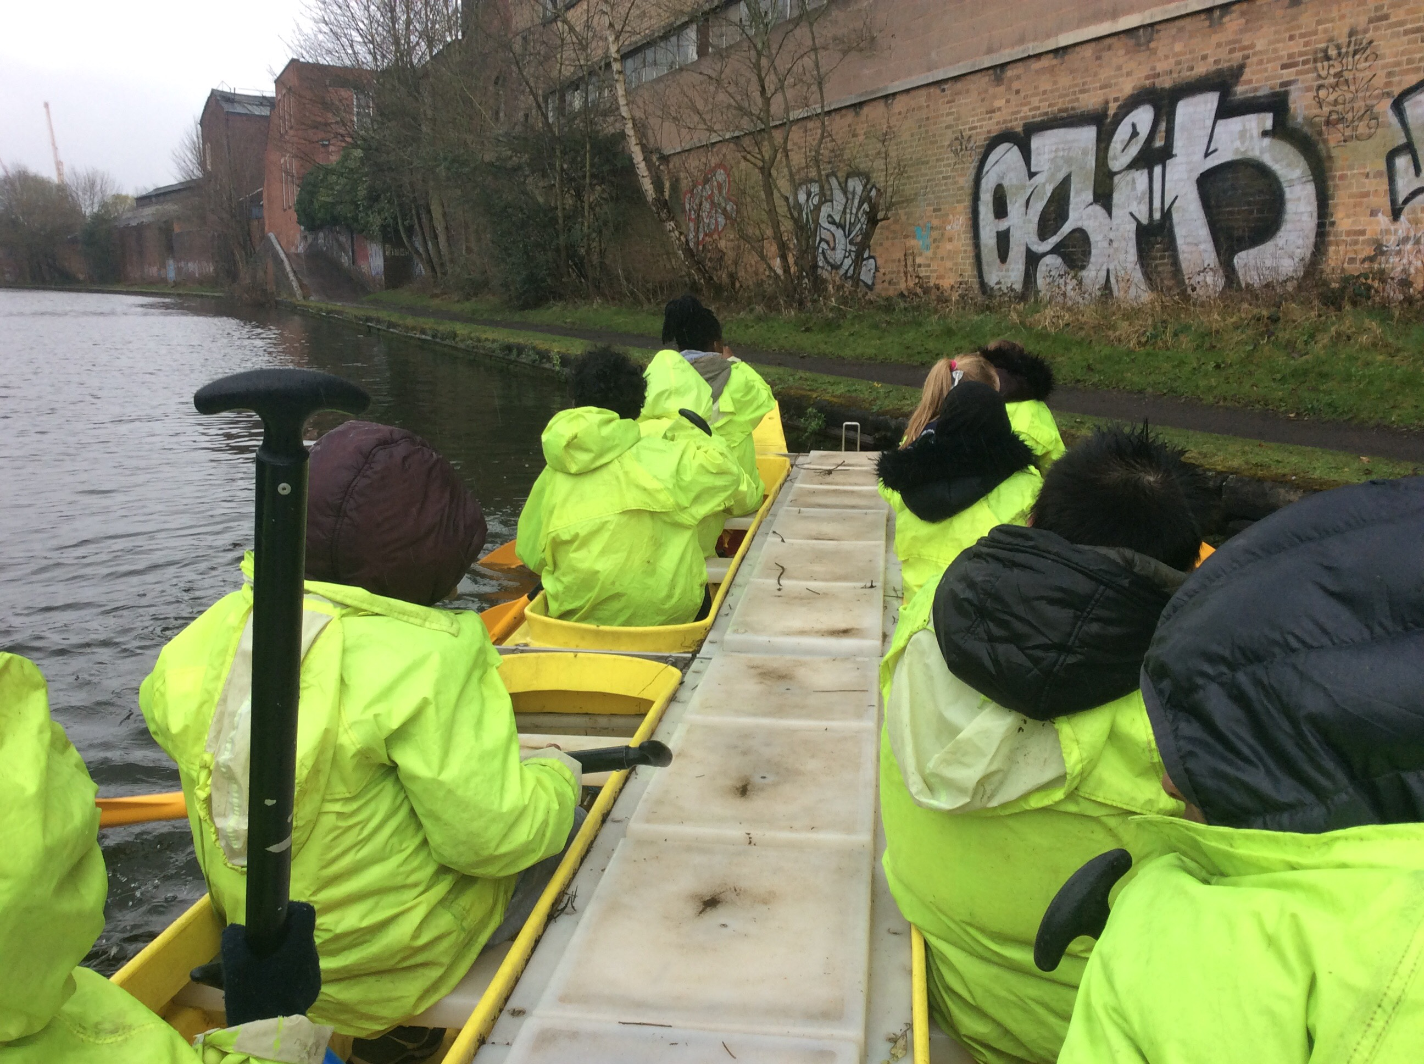

**Polite Reminder**

**Children are NOT allowed to bring chewing gum into school.**



**Spring and Summer Term Dates**

**Easter Holiday Starts**: Monday 15th April 2019

**Summer Term Starts:** Monday 29th April 2019

**World Book Day**

**Thank you to all our parents/carers for your donations. The children looked fantastic. All the money collected will be going to World Book Day Charity.**

Well done to class 6 Lenny for achieving the highest percentage of 97.9% this week.