Oasis Woodview Newsletter
Friday 5th April 2019

In This Issue:
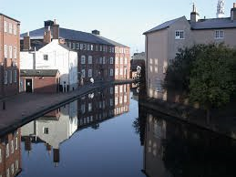
Year 3 visit to Cambrian Wharf
Last week, as part of their topic ‘Flow’, Year 3 explored Birmingham’s canals. During the visit children had the opportunity to learn about the history of canals and the huge part they played in the Industrial Revolution as well as build their own miniature model canal system. The children also helped to serve the community by picking up litter and watering plants in the local area. Finally, they enjoyed a journey on a fabulous canal boat. Everyone thoroughly enjoyed the trip and learnt a lot. It was really pleasing to hear so many members of the public praise the children for their behaviour, manners and community service. Well done Year 3.

Weekly Class Attendance
Get Crackin'
RECAA-86.9% | 3Z-95%
RECBB-93.2% | 4M-92.9%
1CC-95% | 4W-98.2%
1DD-90.8% | 5B-93%
2EE-96.5% | 5M-98.2%
2FF-100% | 6LEN-100%
3C-96.5% | 6LEW-91.3%
Reception, KS1 and KS2 ‘Decorate An Egg’ Competition
Don’t put all your eggs in one basket! Leave one or two out for our ‘Decorate An Egg’ competition. Yes a chocolate Easter egg is up for grabs for the best decorated Easter egg for Reception, KS1 and KS2 children. Children can bring in their decorated eggs into school throughout the week, labelled with their name and class. All eggs will be displayed in our reception lounge. Entries in by 11.4.19. The winners for each stage will be announced during Friday morning’s assembly.
Look forward to seeing your eggs.

Reception and KS1 ‘Do it yourself Competition.
Why not engage with your children this weekend and have a go at helping them decorate their very own Easter Bonnet ready for our judges during Friday morning assembly. There will be a prize for the best decorated Easter Bonnet for Reception and KS1.
Children can bring in their bonnets on Thursday 11th April.
Good Luck!

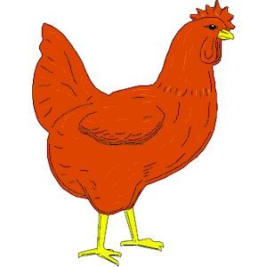

Today was Miss Edwards last day at Oasis Woodview. Miss Edwards has been with us since September 2016 and has been dedicated in serving parents, carers and children at the school. We would like to thank Miss Edwards for all her hard work and wish her all the best for the future.
From all the staff at Oasis Academy Woodview.

Ash End Farm

On Friday 29th March, the children in Reception enjoyed a class trip to Ash End Farm. The children were given the opportunity to see a range of farm animals and to feed them. It was a great experience for the children especially as they were given the chance to pick their own egg from the chicken coop to take home. We would like to thank the parents for allowing the children to gain this wonderful experience
Dates for your diary
Easter Holiday starts Monday 15th April 2019
School reopens to pupils on Monday 29th April 2019.
Parents Evening on Thursday 11th April 2019 for KS1 and KS2. (A separate letter will be sent out shortly)

Well done to class 2FF and 6Lenny for achieving 100% attendance this week.

