|  |  |  |  |  |
| --- | --- | --- | --- | --- |
| Oasis Woodview Newsletter  **Friday 28th February 2020**  faces_line |  | |  | | --- | | O:\ADMIN\Logos and letterheads\Oasis Academy Woodview  Logos and letterheads\Woodview (print).png | |  | |
|  |  |  |
| **Executive Principal: Mrs Johnson Associate Principal: Mr Broadfield** |  | In This Issue |

Dear parents/carers,

Welcome back! I hope you all had a lovely half term.

The children have settled back into school well this week. We have really enjoyed visiting classes and seeing lots of hard work going on in school. The children have particularly enjoyed seeing new books arrive in our fantastic library.

The more you read, the more you succeed!

You may also have noticed our new custom-made parking signs outside the school. Our PCSOs continue to monitor parking on a weekly basis. It’s great to see them issuing fewer tickets! Please continue to park with consideration. Thank you to all who are helping to keep our children safe.

Next Thursday is World Book Day. We can’t wait to see you dressed as your favourite book characters. (The teachers can’t wait to dress up too!)

Thank you all for your continued support. If you have any questions of concerns then please feel free to speak to us.

Have a lovely weekend.

Mr Broadfield and Mrs Johnson



**Spring and Summer Term Dates**

**Thursday 5th March 2020**

**Non Uniform Day -World Book Day**

**Empower Fortnight**

9th March to 22nd March 2020

**Friday 13th March 2020**

**Non Uniform Day – Wear Yellow**

Monday 16th March to Thursday 19th March 2020

**School Book Fair**

**Term Ends:**  Friday 3rd April 2020

**Easter Holiday Starts:**

Monday 6th April to Friday 17th April 2020

**Summer Term Starts:**

Monday 20th April 2020

**Early May Bank Holiday (VE DAY)**

Friday 8th May 2020

**Half Term Holiday:**

Monday 25th May 2020 to Friday 29th May 2020

**Term Ends**:

Monday 20th July 2020





**On Thursday 5th March, children can dress as their favourite book character for World Book Day and spread the love of reading.**

The **Book Fair** will be running in school from **Monday 16th March - Thursday 19th March.**During the week children will have access to the book fair during school time.

Anyone is welcome to come and purchase a book after school on any of the days.

**If you wouldn't mind giving up some of your time, can I have as many helpers as possible from 3.15pm - 4pm each day?**

## Weekly Attendance

10/02/2020 - 14/02/2020

|  |  |
| --- | --- |
| **REC AA:**  **98.6%** | **REC BB: 95.5%** |
| **1CC: 93.8%** | **1DD: 94.5%** |
| **2EE: 93.8%** | **2FF: 94.8%** |
| **3C: 98.0%** | **3Z: 94.0%** |
| **4M: 96.2%** | **4W: 95.9%** |
| **5B: 93.9%** | **5M: 97.4%** |
| **6 Lenny: 97.0%** | **6 Lewis: 97.4%** |

**School Dinner – Theme Day – Thursday 5th March**

To celebrate World Book day on Thursday 5th March we will be having a special theme day lunch. Letters have been sent out this week to give the children who normally have a packed lunch the opportunity to have a school dinner for that day. No payment is required for children in reception year 1 and year 2. Please return your reply slip with payment, if required, by Tuesday 3rd March.

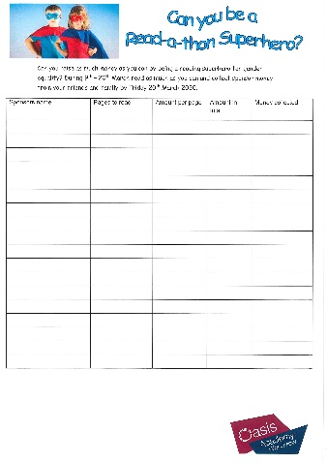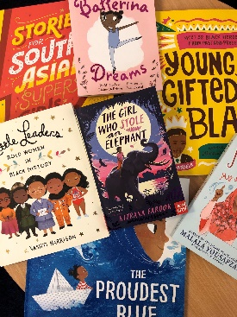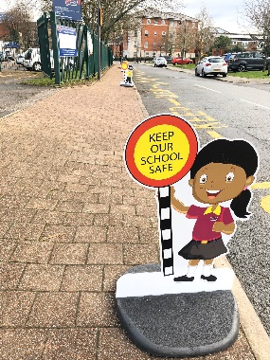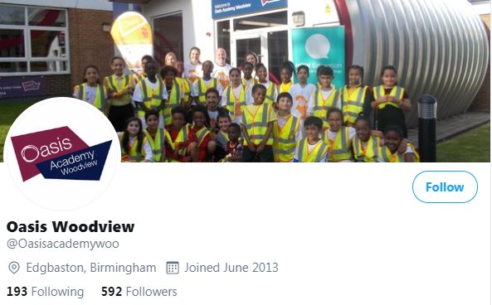

* **An Empower Readathon** **– this will take place over the two weeks 9th to 22nd March.**

Please read as many pages as you can and collect sponsorships from your friends and families –

please bring in your sponsor from and money collected on **Friday 20th March.**

**( Spare forms are available in the office )**

The money raised will help us to:

1. Teach girls in Uganda and Mozambique about their rights, including their right to say no to child marriage;
2. Protect and support women in Zimbabwe, South Africa, India, Belgium and the UK from gender based violence;
3. Run human rights camps and vocational training courses for young girl care leavers in Kyrgyzstan;
4. Teach women in Mozambique about their basic human rights including their right to own their own land;
5. Provide more girls with access to an education at Oasis Academy Musoto in Uganda;
6. Run vocational training courses and human rights training for vulnerable women and girls in India.

**We are asking for all our children to get involved and help raise money by taking part in;**

**ONE OASIS EMPOWER FORTNIGHT: 9th to 22nd March 2020**

**At Woodview we are excited to be taking part alongside our Oasis Academies to help raise money for gender equality during ‘Empower Fortnight’.** All Oasis Academies are working together to raise our **minimum fundraising target of £20,000** over the fortnight.

Pictures from Twitter follow us @oasisacademywoo



* **A non- school uniform day** – please wear as much **yellow** as you can to support gender equality and bring in a donation of 50p on **Friday 13th March.**

**Update Regarding Coronavirus (COVID-19)**

**Please look at our website** [**www.oasiswoodview.org**](http://www.oasiswoodview.org) **for the latest information on the Coronavirus.**