|  |  |  |  |  |
| --- | --- | --- | --- | --- |
| Oasis Woodview Newsletter  **Friday 13th December 2019**  faces_line |  | |  | | --- | | O:\ADMIN\Logos and letterheads\Oasis Academy Woodview  Logos and letterheads\Woodview (print).png | |  | |
|  |  |  |
| **Executive Principal: Mrs Johnson Associate Principal: Mr Broadfield** |  | In This Issue |



Dear parents and carers,

I can’t believe we are about to enter the final week of term. Time flies when you are having fun! Today has seen school full of Christmas jumpers and children getting into the festive spirit.

It was lovely to see many of you this week at parents’ evening. It is great that our children have such supportive parents who work so well in partnership with the school. It was really pleasing to see so many positive comments on the parent questionnaires – thank you!

This morning, our PCSOs were joined by our local community police officers to monitor parking around school and issue advice to motorists about rules and regulations. I am delighted to say that the behaviour of motorists was exemplary – no tickets were issued! A big thank you to our PCSOs and Mrs Shipway for giving up their time to help make our roads a safer place. Thank you parents/carers for your support and please continue to park considerately and keep our children safe.

Last night, a group of year 6 children from Oasis Academy Woodview, and our good friends at Oasis Academy Foundry, travelled to Manchester to watch Manchester United play in the Europa League. This was an amazing experience for the children who are sure to never forget their first taste of live football. The children (most of whom are Manchester United fans) were lucky enough to see four goals and a United victory. There were a few tired children in Year 6 this morning but they all thoroughly enjoyed it!

Next week we look forward to welcoming you to all of our Christmas performances and our Community Christmas Fayre. Thank you to all who have helped with the organisation and donated items.

Thank you all for your continued support. If you have any questions or concerns, please feel free to talk to us.

Have a great weekend

Mr Broadfield and Mrs Johnson

**Autumn Term**

**Monday 16th December Reception Nativity 2.00pm**

**Wednesday 18th December KS1 Christmas Performance 2.00pm**

**Thursday 19th December KS2 Christmas Carols - 2.00pm**

**Thursday 19th December 2019**

**Community Christmas Fayre 2.30pm – 5.00pm.**

**Term Ends:**  Friday 20th December 2019

**Spring Term**

Monday 6th January - **INSET DAY – School closed to pupils**

**Term starts** – Tuesday 7th January 2020 to Friday 14th February 2020

**Half Term Holiday:** Monday 17th February to Friday 21st February 2020

**Term Ends:**  Friday 3rd April 2020

## Weekly Attendance - 02/12/19 - 06/12/2019

|  |  |
| --- | --- |
| **REC AA: 93.0%** | **REC BB: 94.4%** |
| **1CC: 86.8%** | **1DD: 95.0%** |
| **2EE: 91.8%** | **2FF: 92.7%** |
| **3C: 98.0%** | **3Z: 96.3%** |
| **4M: 93.9%** | **4W: 94.4%** |
| **5B: 93.9%** | **5M: 91.8%** |
| **6 Lenny: 99.2%** | **6 Lewis: 98.4%** |

**School Dinners :** Please note that we are giving notice that school dinners will be **increasing from £2.00 a day to £2.10 from January 2020.**

Please remember to inform the school office, if your child wishes to change from school dinners to sandwiches or vice versa.

**Notice of one week is required prior to any change being made.**

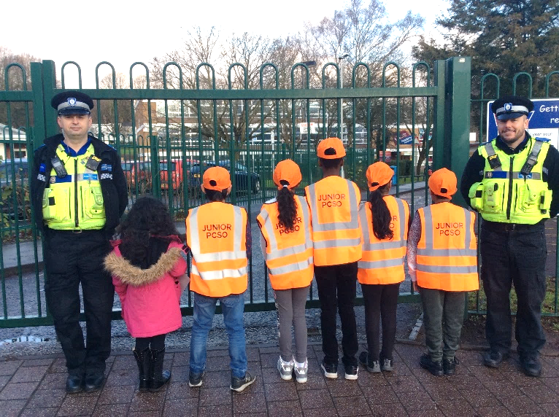

**WE NEED YOUR HELP**

To make our Christmas Fayre a success, we are making a last request for help with the below donations. Please bring any items you can into school by Tuesday 17th December.

**Community Christmas Fayre**

**Including a Taste of Culture**

**Thursday 19th December**

**2.30 pm – 5.00 pm**

**at Oasis Academy Woodview.**

Woodview Drive, Edgbaston, B15 2HU

**STALLS ⚫ GAMES ⚫ RAFFLE PRIZES ⚫ AND MUCH MORE**



**Community Hub Meetings**

Our community hub mornings are open to all parents / carers and are every Thursday morning

9am – 10am.



A picture of our PCSOs with our local community police officers from their patrol this morning.

**BOTTLE TABLE**

**We need unopened, in date bottles for our bottle table at the Christmas Fayre.**

**e.g fizzy pop, squash, still**

**Please bring into school by Tuesday 17th December.**

( no glass bottles please )

**Christmas Performances**

**Monday 16th December - Reception Nativity - 2.00pm**

**Wednesday 18th December KS1 - YEARS 1 & 2 Christmas Performance - 2.00pm**

**Thursday 19th December KS2 - Years 3, 4, 5 and 6 Christmas Carols - 2.00pm**

**Christmas Hampers**

We are asking all KS1 children to bring in coloured items to make up hampers

**Reception RED Yr 1 PURPLE Yr 2 BLACK**

e.g box of malteasers e.g Cadbury’s chocolate e.g Liquorice allsorts

@oasisacademywoo