|  |  |  |  |  |
| --- | --- | --- | --- | --- |
| Oasis Woodview Newsletter  **Friday 6th March 2020**  faces_line |  | |  | | --- | | O:\ADMIN\Logos and letterheads\Oasis Academy Woodview  Logos and letterheads\Woodview (print).png | |  | |
|  |  |  |
| **Executive Principal: Mrs Johnson Associate Principal: Mr Broadfield** |  | In This Issue |

Dear parents/carers

It has been a fun-filled week at Oasis Academy Woodview. On Thursday we celebrated World Book Day. Years 3 and 4 were fortunate enough to see a theatre group perform Alice in Wonderland in our school hall. It was lovely to see so many children (and staff) dressed up in amazing costumes. The children took part in lots of book related activities and thoroughly enjoyed the day. Well done to all those who won prizes for their super costumes.

Yesterday, the school football team played a match against Welsh House Farm. I am delighted to report that we won 10-1. Well done to all the players involved and well done to Mr ‘just call me Pep’ Crowe for training and managing the team so well!

Over the next two weeks, we will be taking part in Empower fortnight (see details below). On Friday children are asked to wear yellow clothes (non-uniform) and make a small donation.

Thank you all for your continued support. If you have any questions or concerns then please feel free to speak to us.

Have a lovely weekend

Mr Broadfield and Mrs Johnson



**Spring and Summer Term Dates**

**Empower Fortnight**

9th March to 22nd March 2020

**Non Uniform Day – Wear Yellow**

**Friday 13th March 2020**

**School Book Fair**

Monday 16th March to Thursday 19th March 2020

**Term Ends:**  Friday 3rd April 2020

**Easter Holiday Starts:**

Monday 6th April to Friday 17th April 2020

**Summer Term Starts:**

Monday 20th April 2020

**Early May Bank Holiday (VE DAY)**

Friday 8th May 2020

**Half Term Holiday:**

Monday 25th May 2020 to Friday 29th May 2020

**Term Ends**:

Monday 20th July 2020

**ONE OASIS EMPOWER FORTNIGHT: 9th to 22nd March 2020**

**At Woodview we are excited to be taking part alongside our Oasis Academies to help raise money for gender equality during ‘Empower Fortnight’.**

All Oasis Academies are working together to raise our **minimum fundraising target of £20,000** over the fortnight.

**We are asking for all our children to get involved and help raise money by taking part in;**

**An Empower Readathon– this will take place over the two weeks 9th - 22nd March.**

Please read as many pages as you can and collect sponsorships from your friends and families– please bring in your sponsor form and money collected on **Friday 20th March.** (Spare forms are available in the office)

****

## Weekly Attendance

24/02/2020 - 28/02/2020

|  |  |
| --- | --- |
| **REC AA:**  **98.0%** | **REC BB: 95.5%** |
| **1CC: 93.4%** | **1DD: 95.4%** |
| **2EE: 93.9%** | **2FF: 96.0%** |
| **3C: 98.0%** | **3Z: 95.0%** |
| **4M: 93.1%** | **4W: 99.3%** |
| **5B: 95.6%** | **5M: 95.8%** |
| **6 Lenny: 96.3%** | **6 Lewis: 97.4%** |



World Book Day / Book Fair

Thank you to all the children and staff for their fantastic costumes for World book day. The best dressed children received a prize and certificate in assembly this morning. Miss Riley won the best dressed teacher.

The **Book Fair** will be running in school from **Monday 16th March – Thursday 19th March**. During the week, children will have access to the book fair during school time. Everyone is welcome to come and purchase a book after school on any of the days that week.

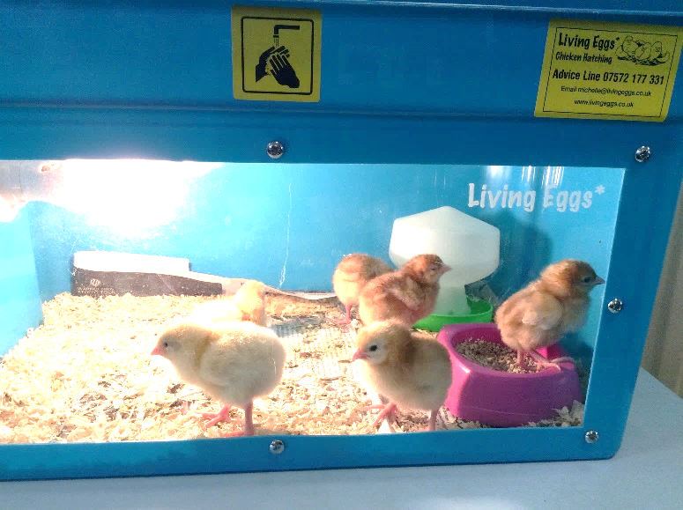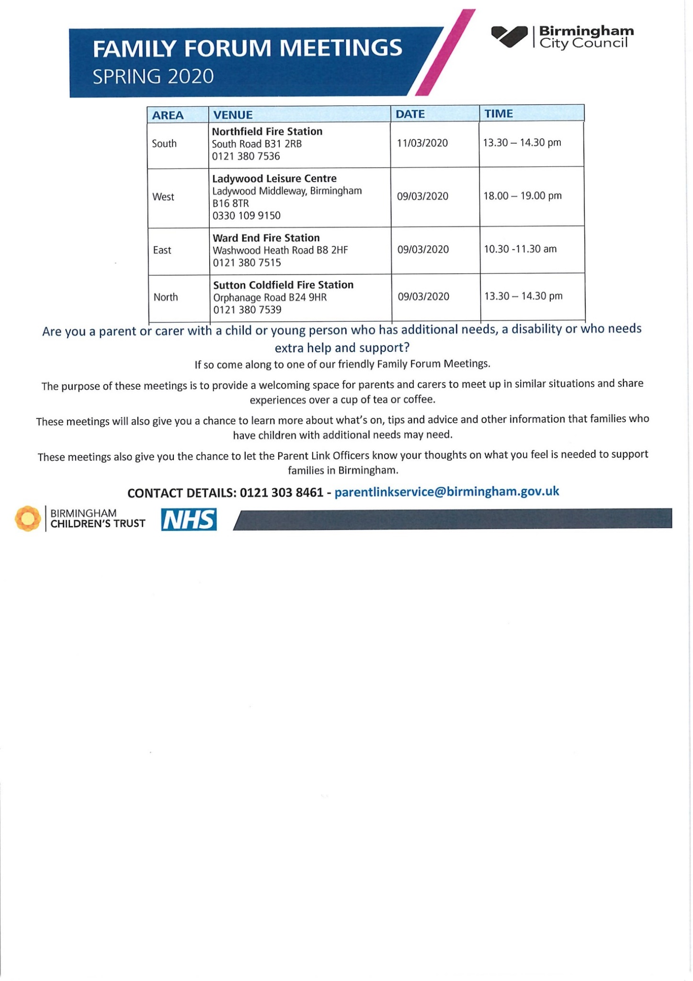

Julia Wagstaff is now offering community support, help with form filling, phone calls, on line applications, careers support, debt advice and listening. Come and have a chat on Thursdays during term time. Arrange a time or drop in – ask at the school office.

**Reception Chicks**

Spring has sprung early in Reception this week with the arrival of a delivery of ready to hatch eggs.

The eggs have been kept warm in an incubator and the children have been looking after the eggs this week waiting patiently for them to hatch. They didn’t have to wait too long with the first egg hatching on Wednesday and the rest soon followed; we currently have 8 chicks.

Next week the children will be able to watch the chicks grow stronger and enjoy their presence in class.

Follow us on Twitter @oasisacademywoo

