Connecting services and communities in ten localities

Monday 20th April. Internal comms to schools, further education and nurseries.
Families are facing significant challenges during the Covid-19 emergency. The nature of the pandemic and impact on income and health means many families who were doing well may now struggle once restrictions are lifted.
Across Birmingham we have had a tremendous response to help these families, from schools checking-in, to the voluntary sector stepping-up, and health, GPs, police, social care and other partners working tirelessly.
But there is a need to coordinate this help in each locality. So Birmingham Children’s Partnership is accelerating plans for a new model of connected services and communities to help families in ten localities across the city. Here are some of the changes for children, young people and families:
- Each of the ten localities will be led by a voluntary sector and public sector partner. There will be frequent partnership meetings to coordinate support.
- All local universal services (e.g. nurseries, schools, GPs) can contact their locality for advice and guidance from professionals. We want to build relationships between local services to serve our communities.
- You will be worried about some families during Covid-19, so local schools and universal services can refer families to the locality arrangements to arrange extra support.
- There will be resilience funding available for individual families in the week commencing 27th April. The money is for emergency help such as food, nappies, medicines, supplies.
- There is a community grant fund for voluntary, community and faith groups who are supporting vulnerable families during the Covid-19 emergency.
Go to www.birmingham.gov.uk/Covid19CYPF for more details including a mind map of locality and city-wide contacts.
The ten localities are: Edgbaston, Northfield, Erdington, Hall Green, Hodge Hill, Ladywood, Perry Barr, Selly Oak, Sutton Coalfield and Yardley. We understand that schools are arranged by clusters and GPs are in Primary Care Networks. So these new locality arrangements are about developing personal relationships rather than being focused on geographies.
This is part of the Birmingham Children’s Partnership response to Covid-19 for our vulnerable families. Birmingham Children’s Partnership includes Birmingham City Council, Birmingham Children’s Trust, Birmingham and Solihull Clinical Commissioning Group, Birmingham Community Healthcare NHS Foundation Trust, Birmingham Women’s and Children’s NHS Foundation Trust and West Midlands Police.

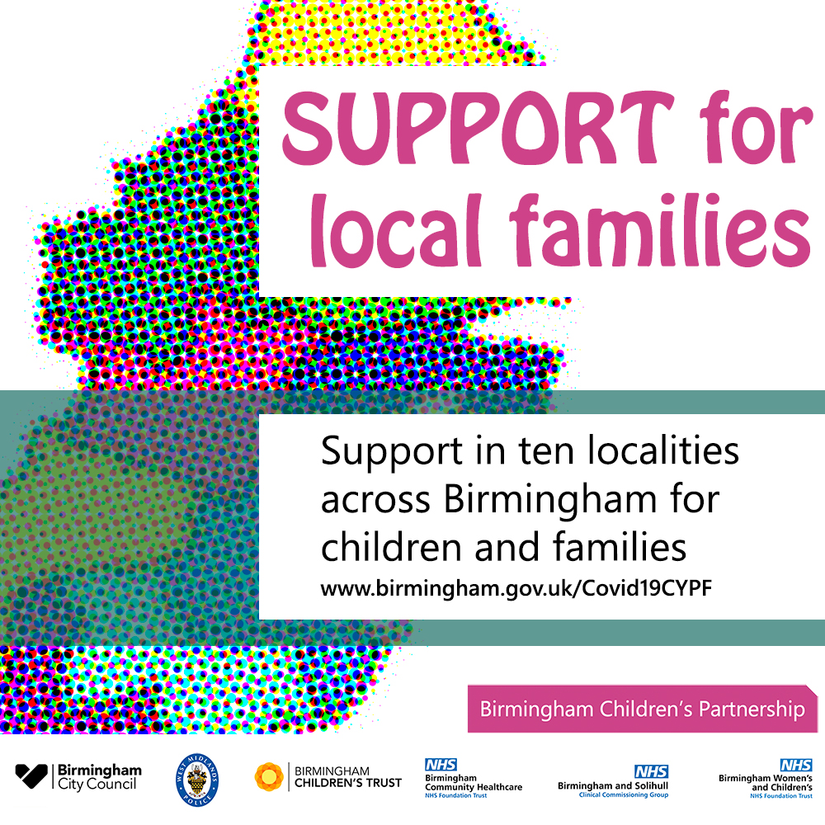
Covid-19 Early Help for families in ten localities

Monday 20th April. Internal comms to VCS, GPs, partners.
Families are facing significant challenges during the Covid-19 emergency, and many will continue to have greater needs once the restrictions have lifted.
Across Birmingham we have had a tremendous response to help these families, from schools checking-in, to the voluntary sector stepping-up, and health, GPs, police, social care and other partners working tirelessly.
But there is a need to coordinate early help in each locality. So Birmingham Children’s Partnership is accelerating plans for a new model of connected services and communities to help families in ten localities across the city. Here are some of the changes for children, young people and families:
- Each of the ten localities will be led by a voluntary sector and public sector partner. There will be frequent partnership meetings to coordinate support.
- All local universal services (e.g. nurseries, schools, GPs) can contact their locality for advice and guidance from early help professionals. We want to build relationships between local services to serve our communities.
- You will be worried about some families during Covid-19, so local schools and universal services can refer families to the locality arrangements to arrange extra support.
- There will be resilience funding available for individual families in the week commencing 27th April. The money is for emergency help such as food, nappies, medicines, supplies.
- There is a £0.8m community grant fund for voluntary, community and faith groups who are supporting vulnerable families during the Covid-19 emergency.
Go to www.birmingham.gov.uk/Covid19CYPF for more details including a mind map of locality and city-wide contacts.
The ten early help localities are: Edgbaston, Northfield, Erdington, Hall Green, Hodge Hill, Ladywood, Perry Barr, Selly Oak, Sutton Coalfield and Yardley. We understand that schools are arranged by clusters and GPs are in Primary Care Networks. So these new locality arrangements are about developing personal relationships rather than being focused on geographies.
This is part of the Birmingham Children’s Partnership response to Covid-19 for our vulnerable families. Birmingham Children’s Partnership includes Birmingham City Council, Birmingham Children’s Trust, Birmingham and Solihull Clinical Commissioning Group, Birmingham Community Healthcare NHS Foundation Trust, Birmingham Women’s and Children’s NHS Foundation Trust and West Midlands Police.

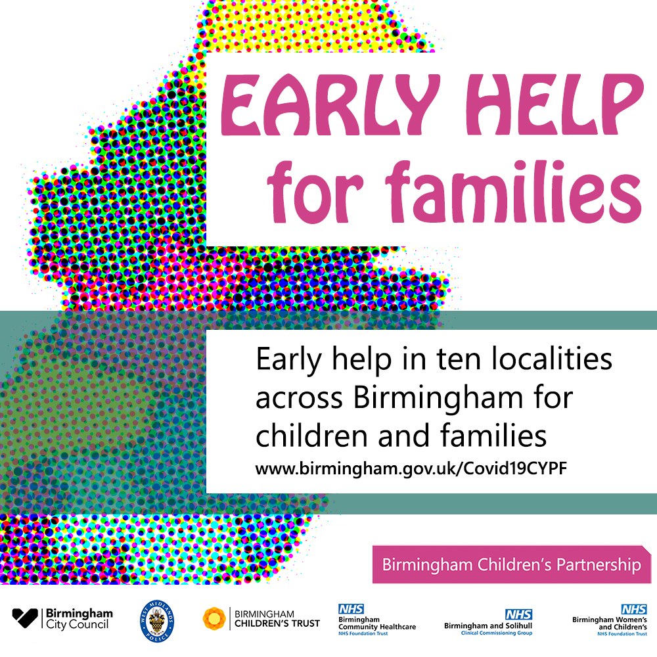

Local early help for families in Birmingham

Monday 20th April. External public comms.
Families have told us about the many challenges they face as a result of the Coronavirus. So partner services across Birmingham are grouping together to support families who are asking for help in each locality.
Community, voluntary and faith sectors, health, family support, social work, police, schools, further education, nurseries, children’s centres, health visitors and GPs are all coordinating local help. This is being delivered in ten localities in the city: Edgbaston, Erdington, Hall Green, Hodge Hill, Ladywood, Northfield, Perry Barr, Selly Oak, Sutton Coalfield and Yardley.
Councillor Kate Booth, Cabinet Member for Children’s Wellbeing said: “This is a hugely challenging time for families in Birmingham. I’m proud how our communities are pulling together, and how the local authority, police and health are working hand in hand with voluntary services and schools.
“The money and new locality support arrangements we have announced today will make a big difference, but it is the commitment and tireless determination from thousands of professionals and volunteers that will be critical for many children, young people and families.”
In each locality, families in need can access:
- Support from voluntary, community and faith groups. Birmingham City Council is investing £0.8m in a community fund to increase local help.
- Mental health support for young people aged 11 to 25 through www.Kooth.com.
- A resilience fund will be available soon to help vulnerable families with emergency items such as food, nappies and supplies.
- Advice and guidance through telephone support in each locality. Partners are working together to contact more families that are asking for help, to make sure they have what they need to cope during the Coronavirus restrictions.
Details of the support available for families can be found at http://www.birmingham.gov.uk/Covid19CYPF
Note that all support will observe social distancing rules whilst restrictions are in place from central government. Across the city there is more early help for families:
- Emergency response hub for vulnerable citizens provided by Birmingham City Council on 0121 303 1116 or http://tiny.cc/w12smz
- Parent Link Contact Line for advice and guidance on 0121 303 8461, support for carers on 0333 006 9711, and the Covid-19 Council helpline 0121 303 1116 for other support such as food supplies, essentials, medication and social contact.
- www.kooth.com for mental health support for young people aged 11 to 25. The Pause service for young people’s emotional wellbeing is now accessed by telephone on 0207 841 4470. And mental health support for adults is through 0121 262 3555.
- Free School Meal voucher scheme for supermarkets — these are emailed to parents or available from schools.
- Local offer for families including for children with special educational needs at www.birmingham.gov.uk/localoffer.
- Birmingham and Solihull Women’s Aid for domestic abuse, telephone 0808 800 0028.
- Local advice and guidance on Coronavirus is available from www.birminghamandsolihullccg.nhs.uk/your-health/coronavirus.

